New Modular Socially Distanced COVID-19 Compliant Classrooms, as seen on ITV News!

Back to school for all with social distancing? Our Modular Classrooms can help mitigate the COVID-19 Teacher and Pupil risk. Ideal to keep children separate who have shielding parents or grandparents.
At Sovereign, we build Permanent / Temporary / Mobile & Modular Buildings that can be easily installed in School Grounds, allowing you to maximise the Pupil: Teacher Ratios, whilst abiding by Social Distancing Rules and Regulations.
Our Modular Buildings allow you to have bigger space Classrooms and enhance your Pupil: Teacher Ratio, with plenty of Ventilation, Hand Sanitiser Dispensers and Fixed Desk Spacing, therefore keeping Pupils and Teachers safe - whilst allowing their very important Education to begin again.

If you are interested in one of our Modular Buildings then please call us on Tel: 01676 549 000 Email: buildings@sov-ex.com

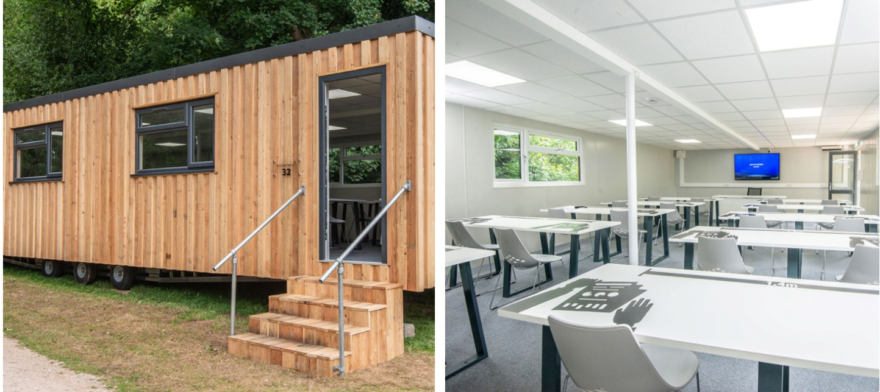

Page 1

Key Features:
Maximise Class Size Occupancy—Fixed Desk Spacing for up to 32 children at 1.4m
Easy Clean Surfaces, Warm, Sturdy and Aesthetically pleasing. Easily wheeled into place on a Field or Playground with a Landrover Installed in a Day.

Further Information:
Fully customisable to meet your needs
Other sizes and finishes available
Temporary or Permanent
Can be fitted-out for another purpose in the future
Can be moved to another location
Can be sold on— as it has an Asset Value
Finance is available*

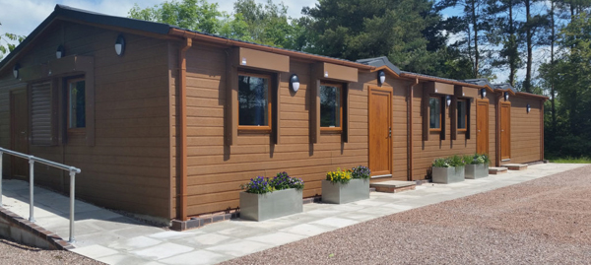

Uses:
- Classroom Offices
- Canteen Nursery Building
- Science Lab Woodland Classroom
- Changing Room Staff Room
- Toilet Block Meeting Room
- Common Room As well as Park Homes and Holiday Homes

Page 2

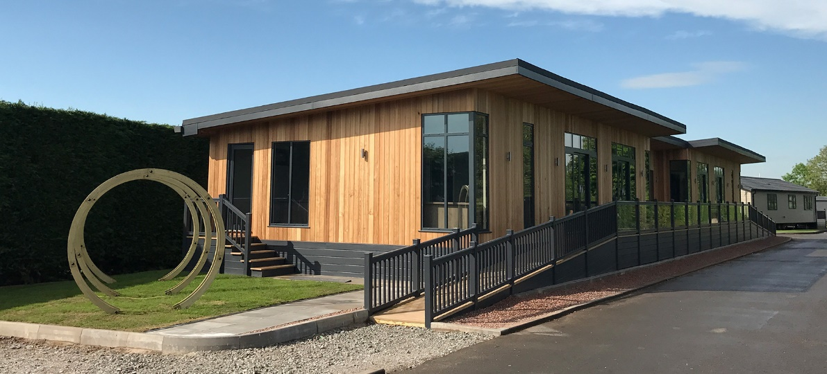

Vincent McCullagh, Managing Director of Sovereign, said the company’s skills and experience meant it took just three weeks from conception to producing a fully workable model, and the firm could produce 40 a week.
He said: “My wife and I have three children and we run a company – so we are fully aware of how hard it is to juggle education and working and there is no question that it will be hard for the economy to recover until children are fully back to school.
“We have been designing and creating temporary buildings for almost 20 years so we are in a position to try to make that process easier for education authorities and teachers.
“It took us just three weeks to design and build the first classroom and we felt it was imperative to have a fully working model for people to experience and the reaction has been extremely encouraging.
“The classroom meets all the relevant Covid-19 safety standards. It features hard floors and fixed desks as well as full heating and ventilation and can be connected to the mains power so is far more suitable than other solutions such as marquees and containers. “In fact, several people have commented that it is far better suited to modern education than many of the permanent classrooms being used!”

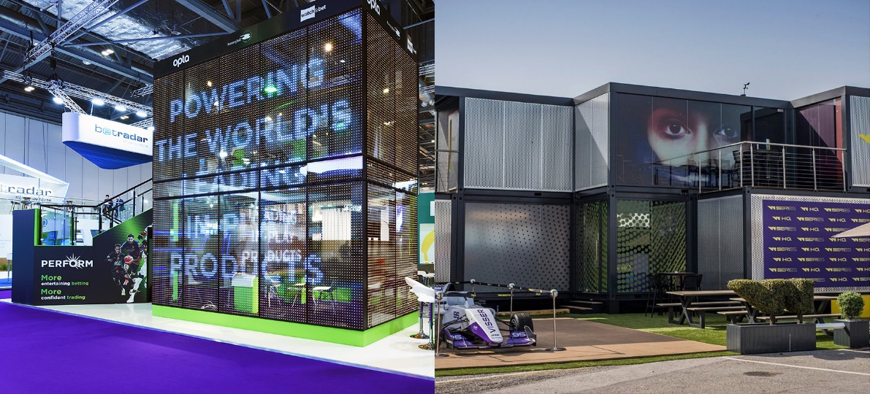

Page 3

